Acceptance test
In BLAST output GUI, custom file result should be the same as UNIPROT file.
Acceptance criteria
Having two tsv files which show the same header
User open the main window
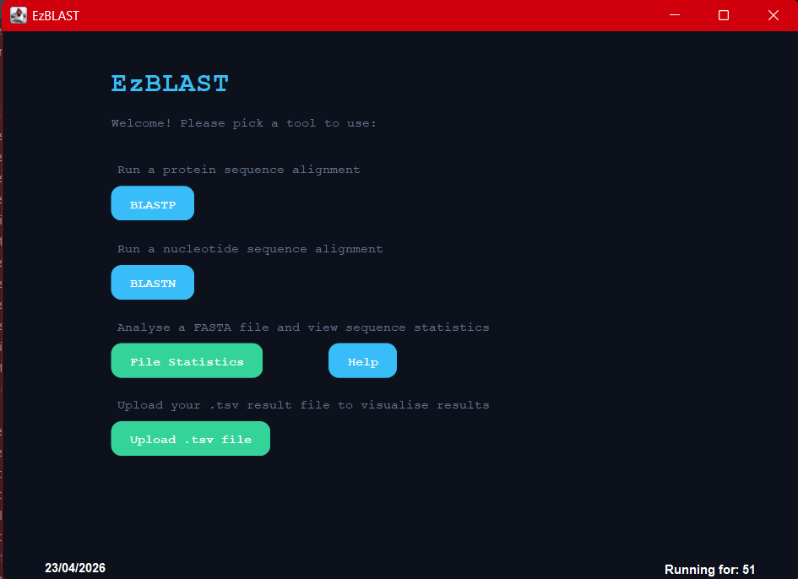

User select blastp algorithm
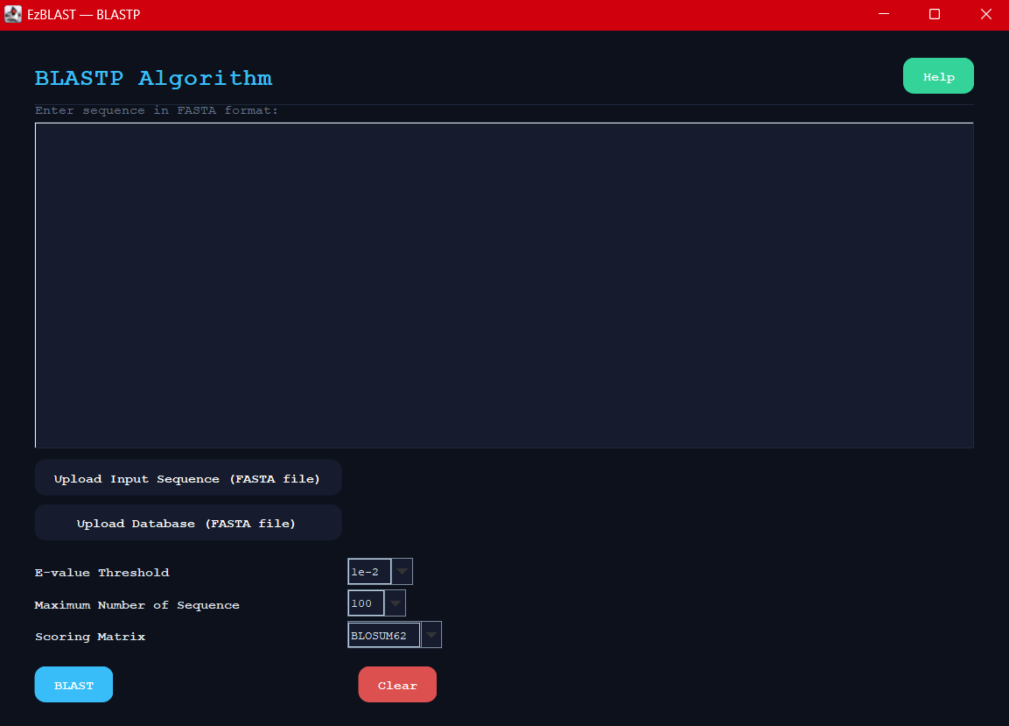

Select query file and run the blastp algorithm
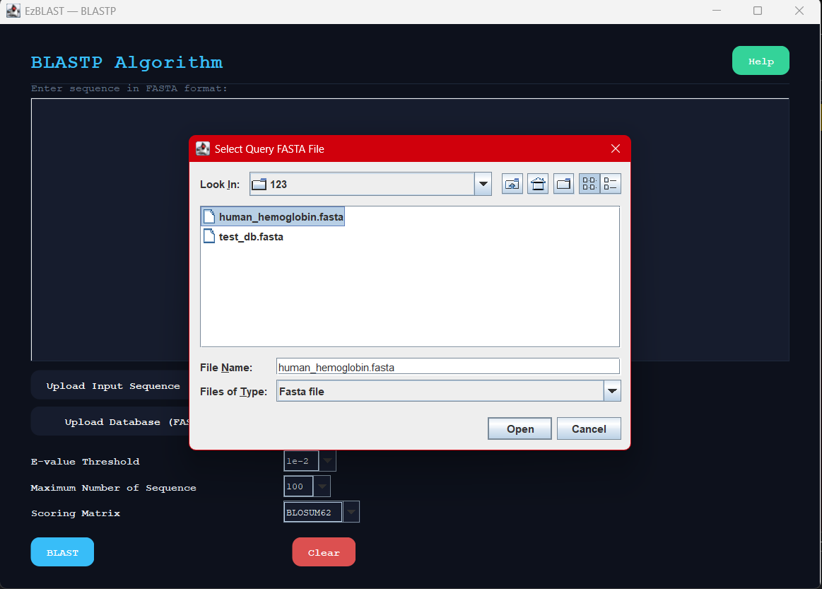

User see the blastp algorithm output from uniprot
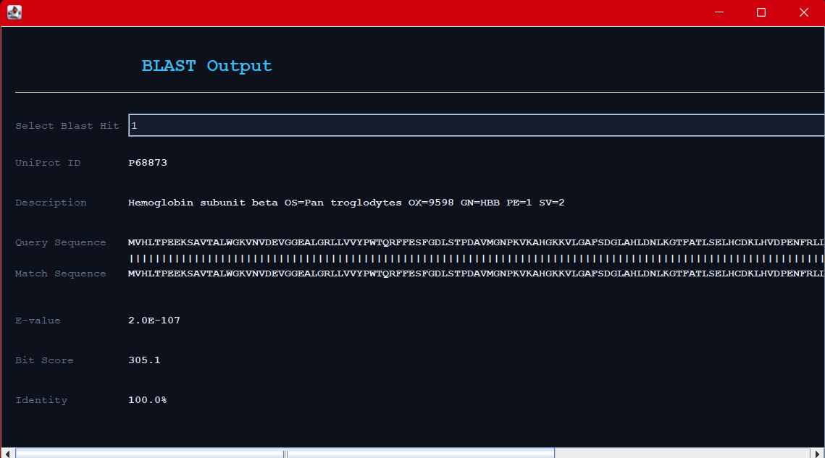

User select tsv file of the saved result and open it
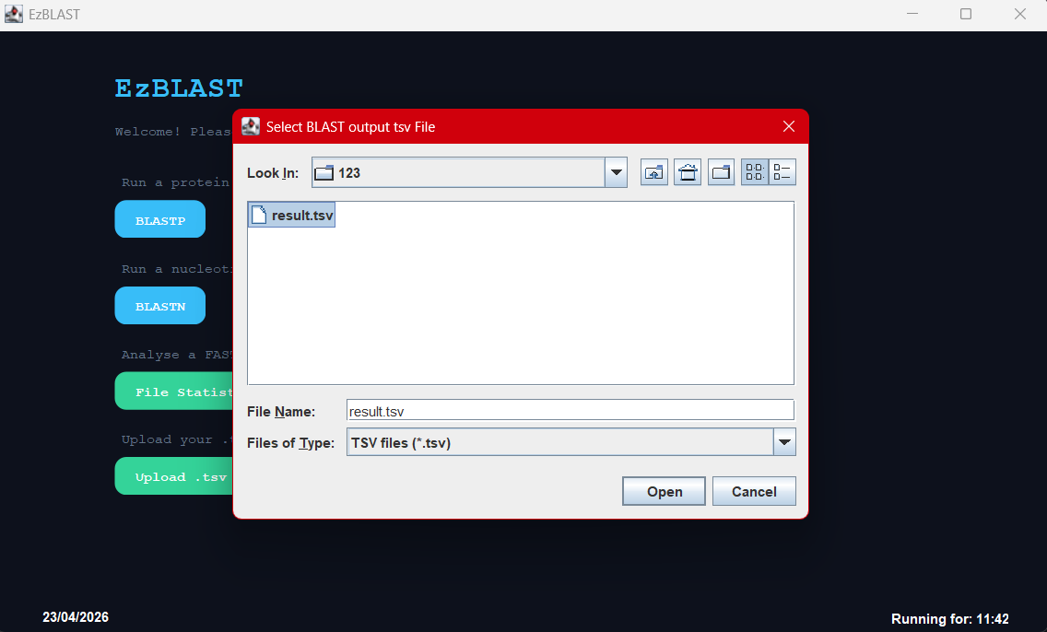

User see same results as Uniprot output
